STANDARD OPERATING PROCEDURE
Getting Started with ChatGPT at Work
A Guide for New Employees
Document ID | SOP-IT-001
Version | 1.0
Date | April 2026
Prepared by | IT Documentation Team
Approved by | Head of People Operations
Review Date | October 2026
Audience | All new employees - onboarding cohort
Classification | Internal Use Only
1. Purpose
This Standard Operating Procedure (SOP) gives new hires detailed instructions on how to access, configure, and use ChatGPT as a productivity tool at work. ChatGPT is an artificial intelligence (AI) application that functions as an assistant. You can write a question or instruction, and it will respond with helpful, human-like prose. In contrast to a simple search engine that provides you with a list of links, ChatGPT reads your request and provides a direct, customised response. In only a few seconds, it can assist you with writing emails, summarising lengthy documents, coming up with ideas, simplifying complicated information, and much more.The purpose of this SOP is to guarantee that all employees start utilising the tool regularly, safely, and in accordance with corporate policy.
By the end of this guide, you will be able to:
- Create and access your ChatGPT account using your company email
- Navigate the ChatGPT interface confidently
- Use ChatGPT effectively for approved work tasks
- Understand and follow the company’s data privacy and acceptable use policies
2. Scope
This SOP applies to all new employees across all departments who are joining the organisation during their first 30 days of employment. It covers the use of ChatGPT for internal productivity purposes only.
This document does not cover:
- Advanced API integrations or developer use cases (refer to SOP-DEV-004)
- Department-specific AI workflows (refer to your line manager for team-specific guidance)
3. Key Terms & Definitions
Term | Definition
ChatGPT | An AI-powered conversational tool developed by OpenAI that generates text responses based on user prompts.
Prompt | The instruction or question you type into ChatGPT to get a response.
LLM (Large Language Model) | The underlying AI technology that powers ChatGPT. It predicts and generates human-like text.
Hallucination | When ChatGPT produces a response that sounds confident but is factually incorrect. Always verify important outputs.
Data Privacy Policy | The company’s rules governing what types of information may and may not be shared with external AI tools.
Acceptable Use Policy (AUP) | The company’s guidelines defining appropriate and inappropriate uses of workplace technology tools.
4. Before You Begin
Before setting up your ChatGPT account, ensure you have the following ready:
- Your official company email address (e.g., firstname.lastname@company.com)
- A stable internet connection
- A supported web browser: Google Chrome, Microsoft Edge, or Mozilla Firefox (latest versions recommended)
- Confirmation from your IT administrator that ChatGPT access is enabled for your role

⚠️ Important: Do not use a personal email address to create your ChatGPT account for work purposes. All work-related AI tool accounts must be registered with your company email to comply with our IT security policy.

5. Step-by-Step Setup Instructions
5.1 Creating Your Account
- Open your browser and navigate to chat.openai.com

- Click the “Sign Up” button on the homepage.



- Select “Continue with Email” and enter your company email address.
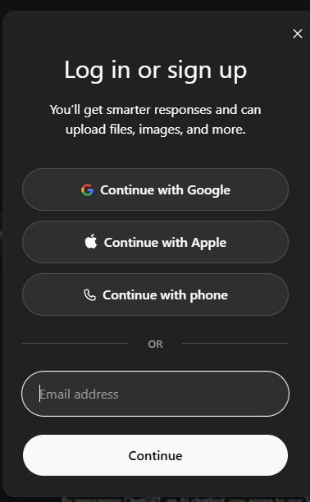
- Check your company inbox for a verification email from OpenAI. Click the verification link inside the email.
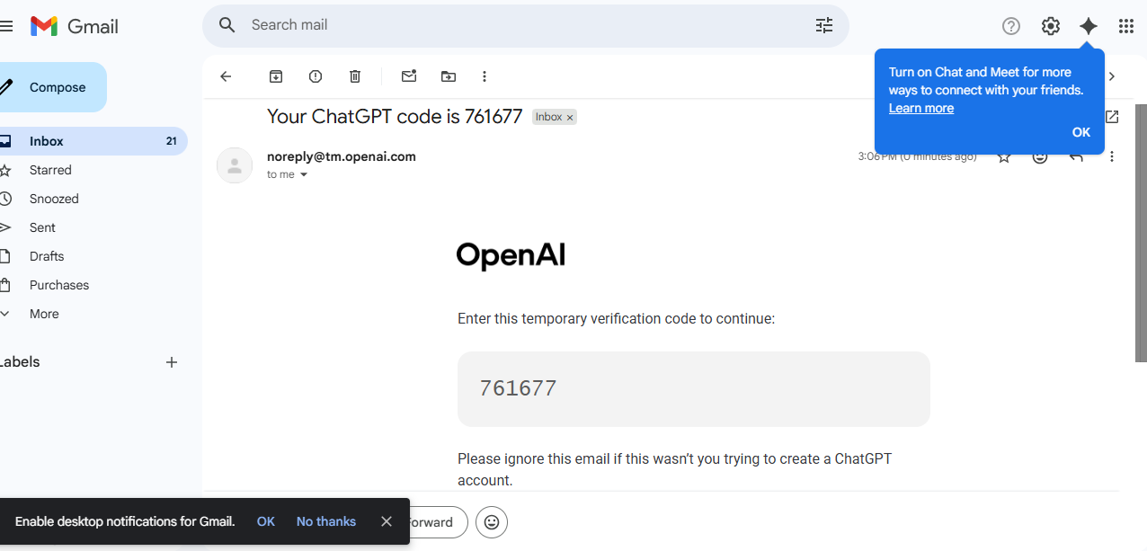
- Set a strong password. Your password must be at least 12 characters and include a mix of uppercase letters, lowercase letters, numbers, and symbols.
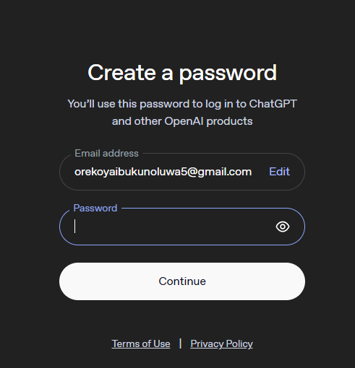

- Complete the short profile setup (name, role). For “Organisation”, enter your company name.
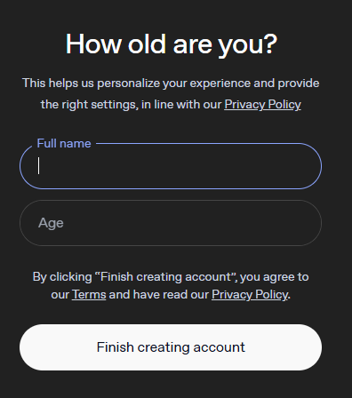

- Accept the Terms of Use. Read them carefully you are agreeing on behalf of your professional conduct.
- You will be taken to the ChatGPT dashboard. Your account is now active.
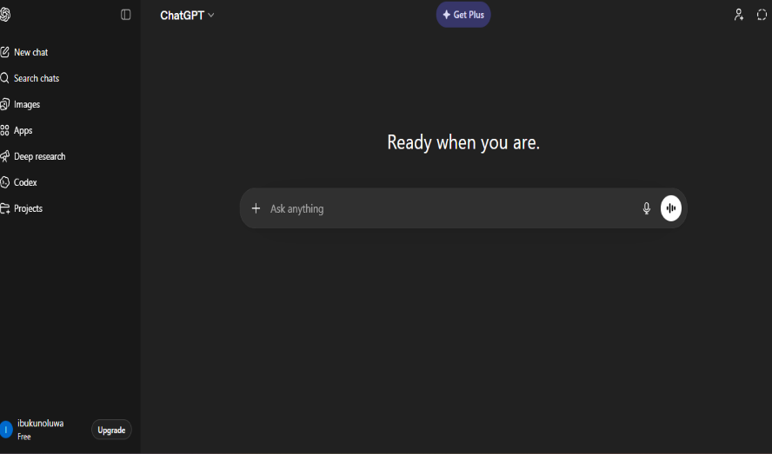
✅ Tip: Once your account is created, bookmark chat.openai.com in your browser for quick access. You only need to sign up once.
5.2 Navigating the Interface
When you log in, you will see the ChatGPT main interface. Here is a quick overview of the key areas:

S/N | Interface Element | What It Does
1 | New Chat button | Starts a fresh conversation. Use this when switching to a new topic or task.
2 | Chat History (left panel) | Shows your previous conversations. Click any item to revisit it.
3 | Message Input Box | Where you type your prompt (question or instruction) for ChatGPT.
4 | Model Selector | Allows you to switch between GPT versions (e.g., GPT-4o). Default is recommended for most tasks.
5 | Response Area | Where ChatGPT’s answer appears. You can copy, regenerate, or give feedback on any response.
6 | Account Menu (bottom left) | Access your settings, manage your account, or log out.
5.3 Writing Your First Prompt

A prompt is the instruction you give ChatGPT. The quality of ChatGPT’s response depends heavily on how clearly you write your prompt. Follow these guidelines:
Be specific and clear
- Weak prompt: “Summarise this.”
- Strong prompt: “Summarise the following client email in 3 bullet points, focusing on the key action items.”
Provide context
- Tell ChatGPT who you are, what the task is, and who the output is for.
- Example: “You are helping an HR officer draft a welcome message for new employees joining a fintech company. Write a warm, professional 3-sentence welcome note.”
Iterate if needed
- If the first response is not quite right, type a follow-up instruction such as: “Make it shorter” or “Use a more formal tone.”
- You do not need to start a new chat ChatGPT remembers the context of your current conversation.
6. Approved Use Cases
ChatGPT may be used for the following work-related tasks:
- Drafting and editing emails, reports, and internal communications
- Summarising long documents or meeting notes
- Brainstorming ideas for projects, campaigns, or presentations
- Writing or reviewing standard operating procedures and process documents
- Creating first drafts of presentations or training materials
- Answering general knowledge questions to support research
- Translating content into other languages for review (final translation must be verified by a qualified speaker.
7. Data Privacy & Acceptable Use Policy

⚠️Critical - Read Carefully: Failure to comply with the data privacy rules below may result in disciplinary action in accordance with company policy.
7.1 What You Must NEVER Enter into ChatGPT
ChatGPT is an external tool. Any information you type into it may be processed and stored by OpenAI on its servers. You must never enter:
- Client names, account numbers, or any personally identifiable information (PII)
- Confidential financial data, contracts, or pricing information
- Employee personal data (salaries, performance reviews, health records)
- Proprietary company strategies, product roadmaps, or trade secrets
- Login credentials, passwords, or access tokens of any kind
- Any information marked CONFIDENTIAL or RESTRICTED in company systems
7.2 Safe Practices
- Always anonymise or generalise data before using it in a prompt. Replace real names with “Client A” or “Employee X”.
- Treat ChatGPT like a public forum do not share anything you would not say in an open meeting.
- Always review and verify ChatGPT’s output before using it in official documents or communications.
- Do not copy ChatGPT responses word-for-word into client-facing documents without editing and fact-checking.
8. Troubleshooting Common Issues
Issue | Possible Cause | Resolution
Verification email not received | Email may be in spam or junk folder | Check spam/junk folder. If not found after 10 minutes, contact IT support.
Cannot log in after account creation | Incorrect password or browser cache issue | Reset your password via the login page. Clear browser cache and try again.
ChatGPT response is cut off mid-sentence | Response exceeded the output limit | Type “Continue” in the message box and ChatGPT will complete the response.
Response is inaccurate or incorrect | AI hallucination a known limitation | Do not use the output as-is. Rephrase your prompt with more context, or verify the information independently.
Page not loading | Network connectivity or browser issue | Check your internet connection. Try a different browser. Contact IT if the issue persists.
Account flagged or suspended | Possible policy violation | Stop using the account immediately and contact your IT administrator.
9. Support & Escalation
If you encounter an issue not covered in the troubleshooting table above, use the following escalation path:

- Check this SOP document for guidance.
- Contact the IT Helpdesk via helpdesk@company.com or extension 100.
- If the issue involves a potential data breach or security concern, escalate immediately to the Information Security team at security@company.com.
- For questions about what is or is not permitted when using ChatGPT, contact your line manager or the Compliance team.

ℹ️ Note: IT support is available Monday to Friday, 8:00 AM - 6:00 PM (WAT). For urgent security issues, a 24/7 hotline is available contact your onboarding coordinator for the number.

10. Document Review & Version Control
This document is reviewed every six months or when significant changes to the tool or company policy occur. The most current version is always available on the company intranet under IT Policies & Procedures.

Version | Date | Description of Changes | Author
1.0 | April 2026 | Initial document created | IT Documentation Team

END OF DOCUMENT - SOP-IT-001 | Version 1.
SS0 | April 2026

